SET - Missing Adults Protocol

(Version 5 – Dec 2022)

Document Control Sheet

Title: | Missing protocol - Adults missing from care homes, hospitals and mental health units
Purpose: | To provide guidance on adults that are at risk of going missing or have gone missing.
Type: | Guidance
Target Audience: | Anyone who is working with adults with care and support needs
Date approved: Review Date: | December 2022  December 2025
This replaces: | Missing protocol - Adults missing from care homes, hospitals and mental health establishments 2020 V4
This should be read alongside: | This document is compliant with all relevant legislation at the time of publication and adheres to the current  SET Safeguarding Adult Guidelines
Leads / Authors: | Jules Bottazzi and Sgt Julia Harvie (Essex Police)
Date/Version | Version 5 - December 2022

Contents
Introduction 4
The Definition of ‘Missing’ 4
What to expect when a report is made to the police 5
Media Strategy 7
When the person is found and identified 7
Missing Person found deceased 8
Missing Mental Health Patients 8
Missing Persons who may lack mental capacity 9
Herbert Protocol 9
Local Authority response 10
Data Protection and consent 10

Introduction
This protocol has been developed by Southend, Essex and Thurrock (SET) Safeguarding Adult Boards to provide a consistent and joined up approach for adults that are at risk of going missing or have gone missing. It reflects policies and procedures within SET and Essex Police. This protocol should be reviewed every three years and in line with all SET policies to ensure consistency and accuracy.

The Definition of ‘Missing’
This protocol uses the National Multi-Agency definition of a Missing Adult:
A missing person is anyone whose whereabouts can’t be established and:
● The context suggests the person may be a victim of crime; or
● The person is at risk of harm to themselves or another; or
● Where there is particular concern because the circumstances are out of character, or there are ongoing concerns for their safety because of a previous pattern of going missing.
This is not the national police definition of a missing person as a need has been identified for a more specific version for the purpose of multi-agency understanding. The police definition allows for a broad range of circumstances within which the police can make an assessment of risk and decide appropriate action. This multi-agency definition aims to provide more clarity on the circumstances that should trigger action by professionals to find and safeguard someone by including the context of risk.
It is recognised that a person over 18 years with mental capacity may be missing through their own choice. Their right to privacy must be observed and details of their location not divulged if this is their expressed decision.
If there are however concerns about the safety and well-being of the person, a decision may have to be taken to share the details of the location with relevant agencies and within the context of statutorily duties and powers to enable safeguarding actions to be taken e.g. assessment under Mental Health Act 1983 (MHA) or Mental Capacity Act 2005 (MCA).
There are many reasons why an adult may go missing from hospital or a health or care setting, including mental ill health, dementia or being a care leaver (missing young adults who were previously in looked-after care are recognised as particularly vulnerable to missing episodes and associated exploitation).
There are many other known factors that can contribute to an increased risk of an adult going missing. These include (but are not limited to):
● Living in supported accommodation – Adults who live in supported accommodation are more likely to go missing due to a multitude of factors including substance misuse, associations and risk of exploitation. It is important that residents within supported accommodation provision are appropriately assessed for the likelihood of going missing and the specific risks associated with being missing assessed on each occasion for that individual.
● Substance misuse – Adults are more vulnerable to all types of exploitation and missing episodes whilst misusing substances. Vulnerability increases whilst under the influence of substances, and when trying to obtain money to buy substances.
● Domestic abuse – Domestic abuse can be extremely complex and increase the risk of adults going missing for a myriad of reasons. This could be either the victim going missing, the perpetrator, or in some circumstances it could be both together. Coercion and/or control should always be considered as a contributory factor.
● Learning Disability/Autism/ADHD – According to the charity Missing People, reasons for adults with a Learning Disability going missing could include bullying/ harassment, poor physical and mental health, difficulties in engaging with the police and other agencies, lack of suitable accommodation/homelessness, medication issues, addiction, language and communication issues, behavioural problems, transport (getting lost) and meeting strangers online. (Rickford 2012: People with Intellectual Disabilities Going Missing)
● Exploitation/Modern Day Slavery – Adults experiencing or at risk of exploitation, including Modern Day Slavery, are at increased risk of going missing. They may be missing due to experiencing harm, because they are trying to evade the person(s) who has caused them harm and/or because they do not trust services to help them.

Actions for hospitals/care homes prior to reporting a person missing

What to expect when a report is made to the police
The police will ask questions relating to the circumstances and what actions have already been taken to locate them. There is an expectation that professionals will have made reasonable enquiries prior to contacting police to ensure that the person is truly missing. (Experience shows that most patients who abscond from hospital go home; and we cannot say a person’s “whereabouts cannot be established” if they are at home.) This information will then be loaded onto the police missing person database COMPACT.

Consider and if appropriate:
- Call the missing person, contact their associates and family
- Check CCTV
- Conduct searches of the building/s they are missing from to establish they are not present on the premises
- Complete a risk assessment /review risk assessment.
- If the patient has gone on home leave and not returned, attend the address they are known to be at, assuming there are no identified risks to visiting professionals. The Police should only be asked to assist if there is reasonable cause to suspect physical restraint may be required.
- If the missing person is subject to a court or hospital order, a copy of this should be made available to the police
- Send a recent photo by email to CompactPhotos@essex.pnn.police.uk
The National Framework for Missing Adults includes some useful flowcharts which provide an example of the process that could be followed when professionals have a concern about a person who is not where they are expected to be (Appendix 1). Figure 1 focuses on prevention; figure 2 on reporting a person missing and the investigation; and figure 3 outlines processes when a person returns from missing and monitoring the response for the purpose of improvement.
When it is confirmed, a person is missing, Essex Police will complete a risk assessment and this will be re-assessed at regular intervals when the risk can go up or down in accordance with the information known and the circumstances. Essex Police will grade the missing person as one of three categories:
- Low Risk - The risk of harm to the subject or the public is assessed as possible but minimal. (Children and young people under the age of 18 should not be considered in this classification).
- Medium Risk - The risk of harm to the subject or public is assessed as likely but not serious.
- High Risk - The risk of serious harm to the subject or the public is assessed as very likely.

Actions for police
- The police will check their own systems for information about the missing person and associates, if known
- Police will conduct an investigation and identify a bespoke set of actions depending on the circumstances and risk, this may include further searches and digital/online enquires etc

Media Strategy
Essex Police will consider a media release, including social media for high-risk cases and this will be conducted via the Essex Police Press Office. Local authority press teams should also collaborate in media strategies. A media release will only be used for a medium risk case if it there are particular exacerbating risk factors and it will assist the investigation.

When the person is found and identified
Essex Police will conduct a Found Report with all missing persons on their return as soon as possible after their return and in any case, within 24 hours (in cases of low or medium risk this may be completed by a PCSO). During the interview the interviewing officer will consider the following:
- If they are a victim of crime including sexual abuse
- If they are the victim of physical or mental harm
- Why the person went missing
- If they are likely to go missing again
- Details of movements during time missing
- Details of where they were found
Where a person, aged 18 years or over, who has mental capacity, does not wish their whereabouts to be revealed, the person making the original report will only be told that the missing person has been traced and does not want their whereabouts disclosed. Particular care should be taken where there are obvious cultural and religious sensitivities.
Responses to missing persons need to be considered when the alleged person missing originates from families or communities where honour-based abuse (HBA) or where domestic abuse/violence is known or suspected not to reveal the current whereabouts of the individual which could compromise their safety. Often victims can go missing in order to escape Domestic Abuse, Honour Based Abuse (HBA), Female Genital Mutilation (FGM), Forced Marriage (FM) or Trafficking and can be at risk of significant harm if they return to their family. Some families go to considerable lengths to find the victim who has gone missing. For example, some families may falsely accuse a missing person of a crime in the expectation the police will locate the person for them. They may seek to embellish the report by exaggerating the subject’s vulnerability, when in fact the person is actually trying to flee. Police officers must be mindful that when an adult missing person is located, their whereabouts must not be disclosed to others if this is against their wishes.
A synopsis of any independent return interviews carried out by social care with the individual will be sent to Essex Police from Social Care to the 'Missing Person Liaison Officers' (MissingPersonLiaisonOfficers@essex.pnn.police.uk) inbox.
Missing People – the only UK charity lifeline for anyone affected by someone going missing. For support call 116000 or visit the website www.missingpeople.org.uk

Missing Person found deceased
Where a deceased person is found who is believed to have been reported missing, Essex Police will treat the death as suspicious until confirmed otherwise.

Missing Mental Health Patients
‘Missing’ mental health patients are patients who are missing from a hospital where they were detained under a civil order and escapees are patients who have escaped from the custody of a hospital imposed by a court.
This section applies to a person who has been compulsorily admitted to hospital:

- for assessment under Sections 2 or 4 Mental Health Act 1983 (MHA)for treatment under Sections 3, 5(2), 5(4) or 37 Mental Health Act 1983 (MHA)
- detained in a place of safety under sections 135 and 136 Mental Health Act 1983 (MHA)

A person who has been compulsorily admitted to hospital for treatment or assessment as above, may be granted leave of absence for any period of time authorised by certain members of the hospital staff under Section 17 Mental Health Act. If the person fails to return to hospital on time, or for some reason the leave has been terminated early by a responsible clinician, then they become a missing person; however there is an expectation that the hospital or care setting will make preliminary enquiries as detailed earlier.
Section 18 Mental Health Act provides police officers with the power to return a missing mental health patient to the hospital. However, Section 18 does not provide a power of entry. Entry to premises to enact the Section 18 arrest power is only provided by Section 17(1)(d) PACE where the officer is in pursuit of the patient. This is a limited and unlikely eventuality.
However, while Section 18 provides a power for the police to retake a missing patient, it is primarily the responsibility of the hospital from which the patient is missing to make enquiries to confirm the patient’s location and make their own efforts to retake the patient. The Section 18 power to retake a patient is not limited to police officers. The power is also available to any Approved Mental Health Professional, any officer on the staff of the hospital and any person authorised in writing by the managers of the hospital.
In the case of a rescinded leave of absence, an appropriate written authority signed by the responsible clinician may be requested, prior to any police action.
A patient detained under Section 18 must not be taken to a police station but to a hospital. There is no power to keep a patient at a police station unless they have been detained under Section 135(1) or Section 136 and only in compliance with the Police and Crime Act 2017 (exceptional circumstances).
If a person is missing whilst under any other provisions of the Mental Health Act (MHA), for example under Guardianship, Community Treatment Order (CTO) or conditional discharge, and are a resident of a care or nursing home, this must also be clearly explained to the police, and all relevant authorities need to be informed including the responsible clinician and the Local Authority, to enable a coordinated approach under relevant legislation.

Missing Persons who may lack mental capacity
A person who may lack mental capacity and is deprived of their liberty under the Mental Capacity Act 2005 (MCA) - Deprivation of Liberty Safeguards (DoLs) in a care home or hospital, can be returned where they should be accommodated for the purpose of receiving care and treatment in their best interests. The law enables the Authorities to act upon the DoLS authorisation to bring the missing person back. However, this decision will need to be taken on balance, having assessed the risks to the person. The Local Authority will take the lead in making the decision and attempting to retake the person and, if necessary, the Police will assist in bringing the missing person back. Providers need to have copies of the legal documents available, should it be necessary to verify the legal status of the person (DoLS standard or urgent authorisation, MHA documentation).

In some circumstances, an urgent Court of Protection order may have to be sought in relation to a person who lacks mental capacity and is at immediate risk and where there is no other legal framework that can be relied upon. Equally, in relation to a person who is under coercion and/or duress, a High Court order can be made to allow public authorities access to the person or to order their removal from a certain place. The Police will assist in executing the court order if necessary.

Where a person is being detained under a legal framework eg. DoLS, MHA, Court Order and goes missing, please consider whether neglect or omissions in care on the part of professionals is a contributing factor, in which case a Safeguarding Concern should be sent to local authority.

Repeat missing episodes – Herbert Protocol (Adults at risk of going missing with dementia/Alzheimers)

It is recognised that repeat missing adults are at risk of harm and it is important for all agencies to apply a preventative problem-solving approach to repeat missing episodes.
Within the ‘golden hour’ of a medium / high risk missing episode, it is imperative that as much information is made available as soon as possible to Essex Police.
Therefore in circumstances where it is identified an adult is likely to get lost or go missing, the Herbert Protocol form should be completed.
The nationally acclaimed Herbert Protocol encourages carers to record useful information which could be used in the event of a vulnerable person with dementia going missing. Carers, family members and friends can complete the Herbert Protocol form in advance, which records all vital details, such as medication required, mobile numbers, places previously located, a photograph etc. In a care setting, the care provider, the person at risk or their family can fill in the form. Please seek permission from the person at risk or their next of kin. If neither is possible, the care provider should make a 'best interests' assessment.
The Herbert Protocol form is available here: https://www.essex.police.uk/notices/af/herbert-protocol/

Local Authority response

In accordance with Section 42 of the Care Act 2014, local authorities must make enquiries or ensure others do so, when there is reasonable cause to suspect that an adult in its area:

● has needs for care and support (whether or not the local authority is meeting any of those needs) and;

● is experiencing, or at risk of, abuse or neglect and;

● as a result of those care and support needs is unable to protect themselves from either the risk of, or the experience of, abuse or neglect

Safeguarding adults plans/protection plans devised as a result of a Section 42 enquiry where the person going missing was a feature, might include actions such as:

● completing a trigger plan or appropriate protocol, eg Herbert

● clarity on who will be notified when there is a concern about the person going missing

● assessment of mental capacity in relation to the missing episodes

● consideration of legal powers available e.g. Mental Capacity Act, Mental Health Act, Inherent Jurisdiction

consider whether there is any assistive technology which would support the adult and ensure tech options have been explored

● flagging the person’s vulnerability on relevant agency records

● action against any alleged perpetrators, including disruption activity

● sharing information about the missing person – particularly with Essex Police and hospital trusts.

● agreeing safety plans with the person to reduce risks should they go missing in the future – e.g. where might be a safe place to go, planning how to get home, ability to communicate with someone for help

● addressing the reasons why the person might be going missing

● supporting family members / carers or staff caring for the person who has gone missing.

Data Protection and consent
Any information relating to an identified or identifiable living individual recorded as a consequence of this procedure will be processed in accordance with the Data Protection Act 2018 and General Data Protection Regulations. Where possible and practical the adult should be informed and asked for information to add to the form. They should also be told that it will be kept in the event that they go missing (people with fluctuating capacity) and that it will only be shared with the staff in the establishment and the police and other relevant partners concerned with finding them.
APPENDIX 1 Flow chart of responsibilities: Planning and response if someone is not where they are expected to be

Taken from The multi-agency response for adults missing from health and care settings: A national framework for England - GOV.UK (www.gov.uk)

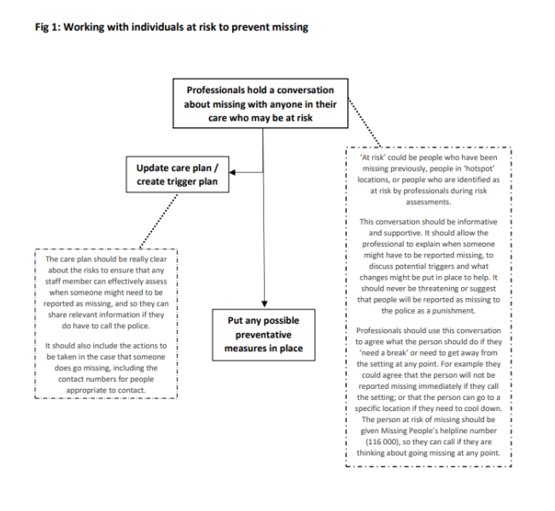

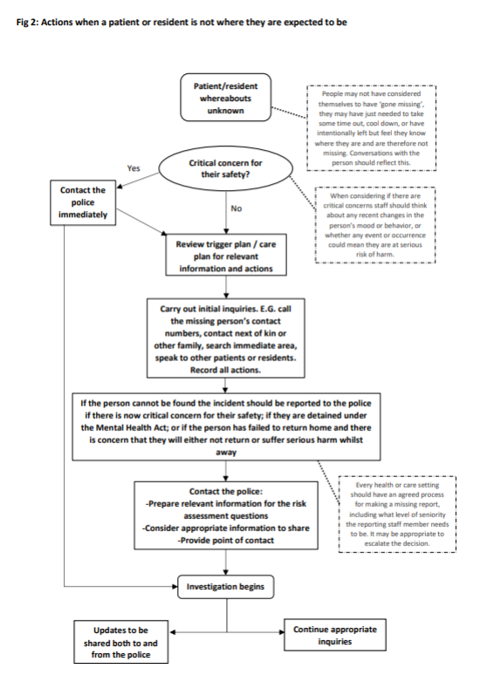

http://www.essexsab.org.uk/professionals/guidance-policies-protocols/

